DUY TAN UNIVERSITY
INTERNATIONAL SCHOOL




INDIVIDUAL ASSIGNMENT
SUBJECT: ASIA COMMUNITY WITH IT
GENERATIVE AI DATA ANALYSIS

SUBMITTED BY
FULL NAME : NGUYEN VAN DUY MANH
STUDENT CODE : 29211100024
SUBJECT CODE : DTE-CS 231 BIS

Da Nang, May 01, 2026
TABLE OF CONTENTS
I. Summary of ChatGPT Results 1
II. Your Explanation of the Results 1
III. Charts and Visualizations 2
3.1. Histogram Chart 2
3.2. Bar Chart 2
3.3. Scatter Plot Chart 3
3.4. Heatmap Chart 3
3.5. Pair Plot Chart 4
3.6. Bubble Chart 4
IV. Your Business Question Analysis 5
V. Evaluation of AI Results 6

I. Summary of ChatGPT Results
Through the exploratory data analysis (EDA) process, key insights extracted from the dataset include:
- Descriptive Statistics:
  - Customer age ranges from 18 to 69 (mean: 43.26 years).
  - Average annual income is approximately $112,760.
  - Mean purchase frequency is 14.75 times per month.
  - Initial mean purchase price was $286.84.
- Categorical Patterns:
  - Gender distribution is perfectly balanced (50.9% Female, 49.1% Male).
  - Technology is the most common occupation (217 users).
  - 'Sports' and 'Golf' tie for highest transaction volume (116 each).
  - App (264) and Credit Card (261) are the top payment methods.
- Missing Values & Outliers:
  - Detected 20 missing values in 'Annual Income'.
  - Flagged 9 extreme outliers in 'Average Purchase Price' (max anomaly: $4,694.60).
- Changes After Preprocessing:
  - Missing income data was imputed using the median.
  - Purchase price outliers were handled via IQR clipping.
  - The maximum price was capped at $745.02, reducing standard deviation from 310.09 to 143.67.
- Correlation Results:
  - Pearson coefficients revealed almost zero linear relationships.
  - Age vs. Purchase Frequency scored -0.061.
  - Annual Income vs. Average Purchase Price scored -0.057.

II. Your Explanation of the Results
Analyzing the AI's output, several critical business and technical realities emerge:
- Demographic Independence: The platform serves a highly diverse user base. Therefore, there is no single "golden" age group or specific income bracket that exclusively dictates overall spending behavior across the store.
- The Myth of Income-Based Spending: The remarkably weak statistical correlation (-0.057) between annual income and purchase price breaks a common traditional marketing assumption. High-income earners do not strictly buy luxury items, and lower-income users still occasionally make premium purchases.
- Data Integrity is Crucial: The data preprocessing phase effectively saved the analytical integrity of the dataset. Without standard IQR clipping, the extreme $4,694.60 outlier would have completely skewed the training weights and accuracy of any future Machine Learning models we build on this data.
- Behavioral Drivers: Since static demographics (like Age/Income) don't strongly correlate with spending, user purchasing behavior is highly likely non-linear. It is highly probable that dynamic factors like specific product preferences, seamless UI/UX design, and targeted promotions drive sales more than static demographic data.

III. Charts and Visualizations

3.1. Histogram Chart
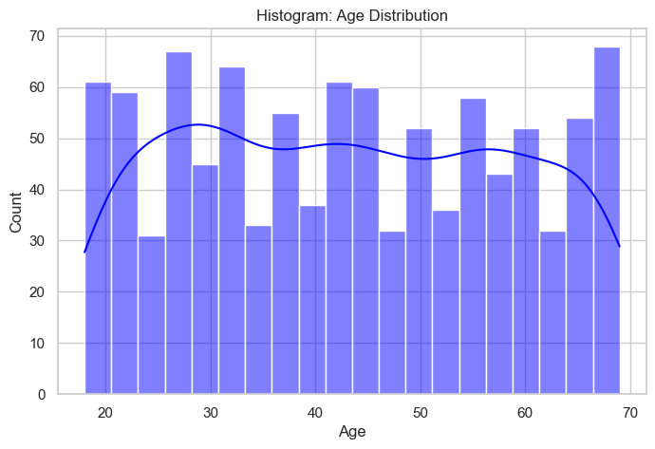
- Visual Structure: A multi-bin histogram with a Kernel Density Estimate (KDE) overlay.
- Insight: The relatively flat distribution curve indicates that the platform appeals almost equally across all generations, requiring a broad, multi-generational marketing approach rather than targeting a single age niche.

3.2. Bar Chart
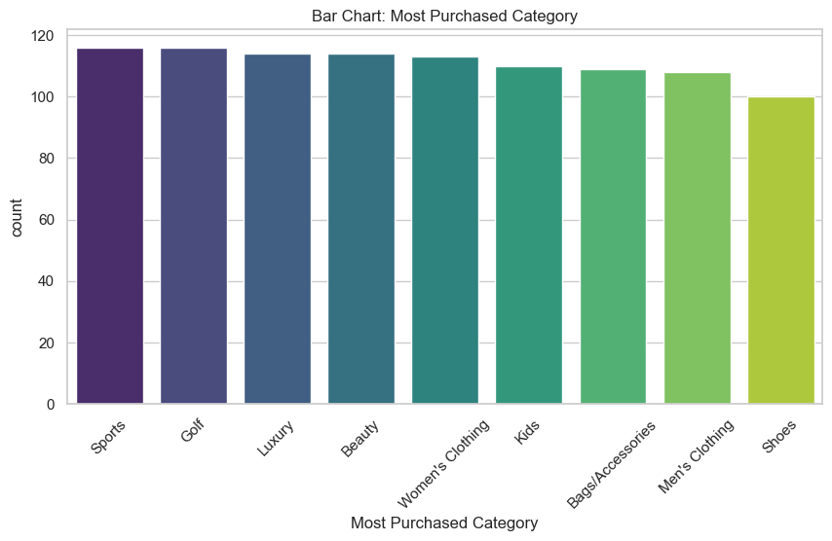
- Visual Structure: A descending bar chart grouping transaction counts by category.
- Insight: 'Sports', 'Golf', and 'Luxury' are the primary volume drivers, suggesting that the core customer base highly values active lifestyle and premium self-care products.

3.3. Scatter Plot Chart
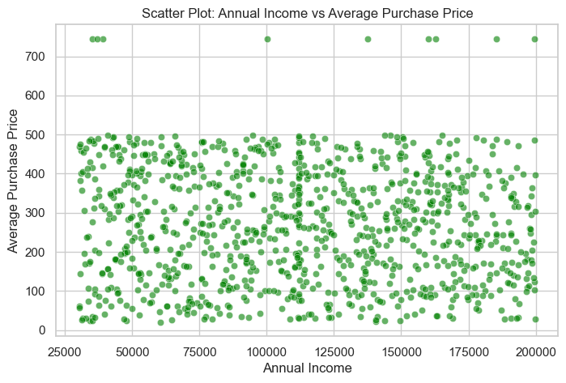
- Visual Structure: A 2D scatter plot mapping Annual Income (X) against Purchase Price (Y).
- Insight: The "shotgun blast" spread of the data points visually confirms the mathematical lack of correlation. It proves that segmentation based purely on income will be ineffective.

3.4. Heatmap Chart

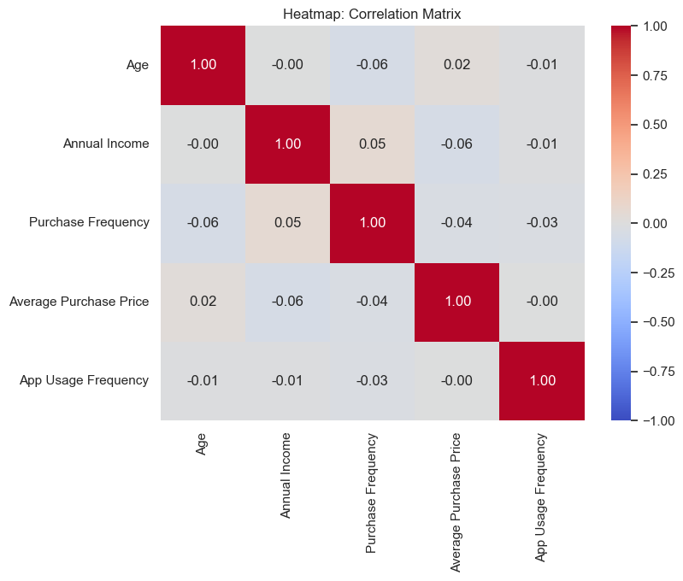
- Visual Structure: A color-coded Pearson correlation matrix.
- Insight: The complete absence of deep red (strong positive) or deep blue (strong negative) squares provides an immediate, executive-level summary that our numerical variables are entirely independent of one another.

3.5. Pair Plot Chart

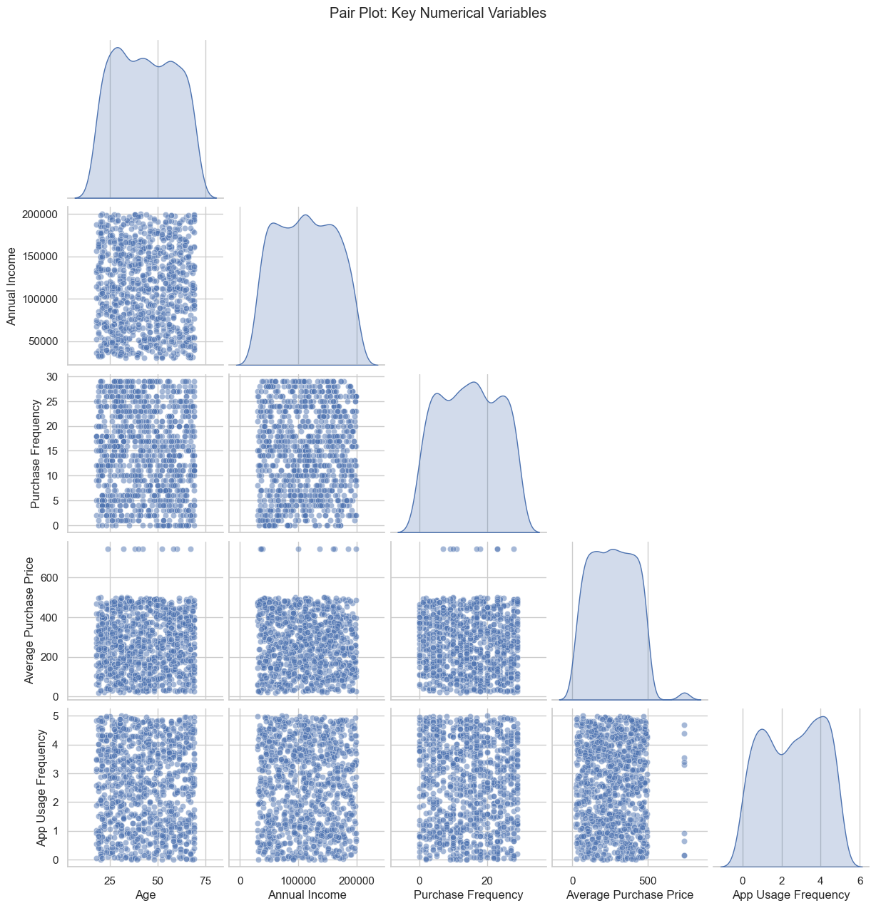
- Visual Structure: A grid combining density curves (diagonal) and scatter plots.
- Insight: It offers a comprehensive multi-dimensional check, verifying that our preprocessing efforts successfully normalized the distribution shapes across all pairings.

3.6. Bubble Chart

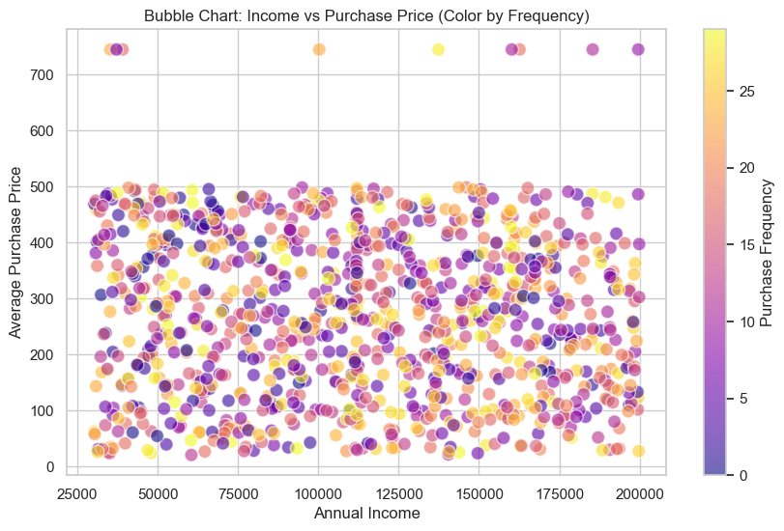
- Visual Structure: A 3D representation using X (Income), Y (Price), and Color (Purchase Frequency).
- Insight: Highly frequent buyers (represented by brighter/distinct colors) are scattered randomly. This means our most loyal customers exist in every income tier, not just the wealthy segments.

IV. Your Business Question Analysis
- Business Question: Which product categories yield the highest Average Order Value (AOV), and how should we strategically allocate our marketing and UI/UX resources accordingly?
- Method:
  - Group the cleaned dataset by 'Most Purchased Category'.
  - Calculate the mean 'Average Purchase Price' for each specific group.
  - Sort the results in descending order and plot them using a comparative bar chart.
- Results:
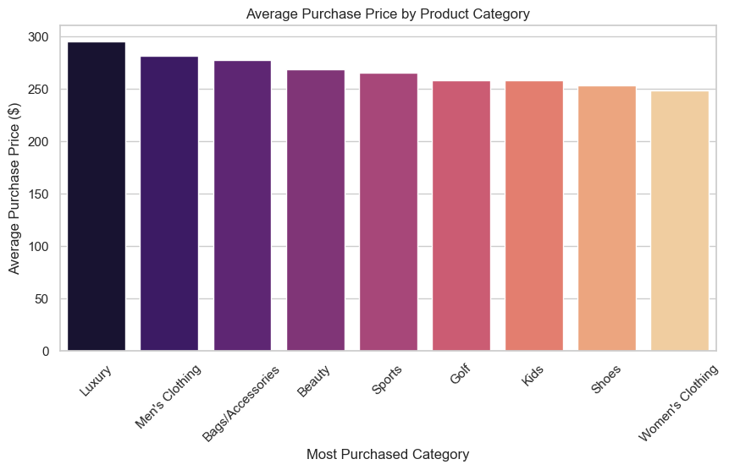
  - The 'Luxury' category dominates with the highest average purchase price at $295.45.
  - 'Men's Clothing' follows closely at $281.77.
  - Conversely, 'Women's Clothing' ($248.26) and 'Shoes' ($252.90) yield the lowest revenue per individual transaction.
- Interpretation:
  - Quantity does not equal Quality. While Women's Clothing might generate high web traffic or transaction volume, it yields a lower price per checkout.
  - Customers buying Luxury and Men's Clothing exhibit a much higher willingness to spend more per single transaction, representing a high-margin segment.
- Business Insight & Action Plan:
  - Resource Allocation: Shift a larger percentage of premium ad spend towards Luxury and Men's Clothing to acquire high-margin customers.
  - Retention: Implement a VIP loyalty program specifically for the Luxury segment to retain these high-value spenders.
  - Sales Tactics: For lower-AOV categories (Women's Clothing/Shoes), deploy aggressive UI cross-selling features (e.g., "Frequently bought together" widgets) and bundling promotions to artificially inflate the basket size per checkout.

V. Evaluation of AI Results
Based on my practical experience with this assignment, Generative AI operates exceptionally well as a computational co-pilot, though it strictly requires human heuristic guidance.
- Strengths (Operational & Technical Efficiency):
  - Accelerated Workflow: Integrating ChatGPT with modern AI-driven IDEs (specifically Cursor and the Antigravity extension) drastically minimized the EDA lifecycle and eliminated boilerplate coding.
  - Computational Precision: The AI demonstrated flawless execution in drafting Python scripts (Pandas, Seaborn). It successfully applied complex statistical transformations, such as mathematical IQR clipping, without syntax errors or the need for manual debugging.
- Limitations (Analytical & Strategic Constraints):
  - Contextual Blindness: The AI operates in a semantic vacuum. While it computes a -0.057 correlation with perfect mathematical accuracy, it lacks the domain knowledge to independently deduce why this occurs within the specific market context.
  - Absence of Business Acumen: AI successfully delivers raw statistical outputs (the data points), but it is incapable of formulating actionable marketing strategies. The critical translation from statistical evidence to strategic business decisions remains an exclusively human task.
Conclusion: Generative AI should not be viewed as an autonomous analyst, but rather as a high-performance execution engine. By offloading the heavy technical lifting and data visualization tasks to AI, analysts can dedicate their cognitive bandwidth entirely to complex business logic and strategic decision-making.

